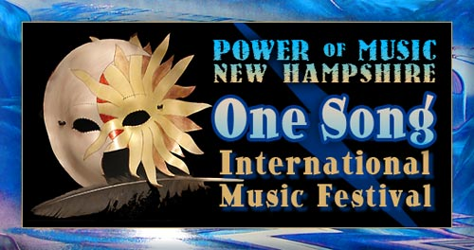
With Innovations for Humanity Summit, Exposition & Conference
powerofmusicnh.com
Event Director: B. Hughes 928-202-1447

Email form to: b@powerofmusicnh.com

Request to Present at the Innovations Summit to Investors
Please include Bios
Name(s):
Project Name:
Phone:
Email:
Address:
Brief Description of What’s Innovative and Helps Humanity:
and/or attach Executive Summary and Financial Projections

